Birla Institute of Technology & Science, Pilani
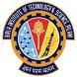
Hyderabad Campus
Computer Science and Information Systems Department
Second Semester 2018-2019 Course Handout (Part II)
Date: 07/01/ 2019
In addition to part-I (General handout for all courses appended to the timetable) this portion gives further specific details regarding the course:
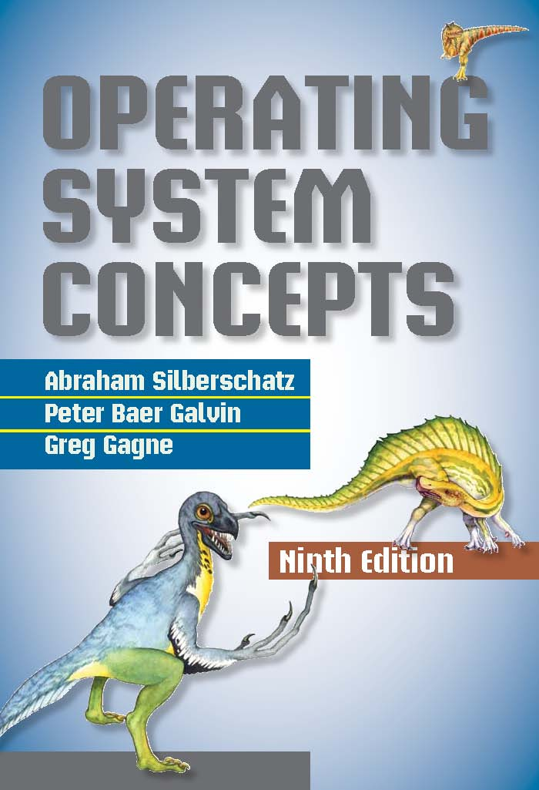

COURSE NO. : CS F372
OPERATING SYSTEMS

Instructor I/C: Sudeepta Mishra, I/C (sudeepta@hyderabad.bits-pilani.ac.in)

Scope:
An operating system (OS) is a collection of software that manages computer hardware resources and provides common services for all computer programs that are executed on the computer. The OS provides an established, convenient, and efficient interface between user programs and the bare hardware of the computer on which it runs. It provides relatively uniform interfaces to access the extremely wide variety of devices that a computer interacts with, from input/output devices such as printers and digital cameras, to multiple processors that are available on a single board. The OS is responsible for sharing resources (e.g., disks, and processors), providing common services needed by many different programs (e.g., access to the printer), and protecting individual programs from interfering with one another. There is a tremendous range and variety of computer systems for which operating systems are being designed: from embedded devices e.g., the on-board computers for the space shuttle or a luxury sedan and cellphones to PCs, workstations, and mainframes, to supercomputers. The intent of this course is to provide a thorough discussion of the fundamentals of operating system design, and to relate these to contemporary design issues and current directions in the development of operating systems.

Objectives:
- To learn about three major OS subsystems: process management (processes, threads, CPU scheduling, synchronization, and deadlock), memory management (segmentation, paging, swapping), and file systems.
- We will also study existing operating systems such as Linux/Windows and learn the way the studied concepts in the course are implemented in these OSs.
TEXT BOOK
T1 Silberschatz, Galvin, and Gagne, “Operating System Concepts”, 8e, John Wiley & Sons, 2009.
REFERENCE BOOKS
R1 W. Stallings, “Operating Systems: Internals and Design Principles”, 6e, Pearson, 2009.
R2 Tanenbaum,Woodhull,“Operating Systems Design & Implementation”,3e, Pears, 2006.

PLAN OF STUDY:
S.  No. | Learning Objectives | Topics to be covered | Chapter in the Text Book | #Lect.s
1. | Various components of a computer and the role an OS play to control those. | Introduction: What OS’s do? System Organization & Architecture, OS Operations, Open source OSs. | Chapter 1 | 3
2. | How a system boots and what functions and services an OS provides. | OS Structures: OS Services, System calls, OS Structures, Virtual machine, System boot. | Chapter 2 | 3
3. | At runtime how does a process work and how they communicate with each other. | Processes: Process Concepts, Scheduling, Operations, Inter Process Communication. | Chapter 3 | 4
4. | Light weight processes and their impact on managing system resources. | Threads: Libraries, Multithreading model, Threading issues. | Chapter 4 | 3
5. | Single and multiple CPU process scheduling. | CPU Scheduling: Criteria, Algorithms, Multiple processor scheduling. | Chapter 5 | 4
6. | How a concurrent access requests are to serialized? | Synchronization: Critical section problem, Peterson’s solution, Semaphores, Classical problems, Monitors. | Chapter 6 | 4
7. | How multiple processes could end up in waiting indefinitely and how to solve this? | Deadlocks: System model, Prevention, Avoidance, Detection, and Recovery from deadlocks. | Chapter 7 | 4
8. | How main memory is divided into different parts and arranged so that degree of multiprogramming can be increased. | Memory Management: Swapping, Contiguous memory allocation, Paging, Segmentation. | Chapter 8 | 4
9. | How to combine the size of RAM and Hard disk to get a Virtual memory so that larger programs can be run. | Virtual Memory: Demand paging, page replacement, Thrashing, Memory mapped files, Allocating Kernel memory. | Chapter 9 | 3
10. | What abstraction OS provides to access contents from a hard disk? | File System Interface: File system, Access methods, Mounting, sharing, and disk structures. | Chapter 10 | 2
11. | How is the FS implementation help improve the efficiency of storage space? | File System Implementation: Structure and Implementation, Allocation methods and Free space management. | Chapter 11 | 2
12. | Secondary storage structures with IO scheduling and redundancy? | Mass Storage: Disk structure, disk scheduling, disk management, and RAID. | Chapter 12 | 2
13. | How OS manages various I/O devices? | I/O Systems: I/O hardware, I/O Interface, Kernel I/O subsystem. | Chapter 13 | 2

EVALUATION SCHEME:
Sl No. | Component | Duration | Weightage | Date and Time | Nature of Component
1. | Quizzes | 30 mins | 40% (20%+20%) | 2 quizzes (Mid Feb, Mid April), 1 makeup (End of April) | Open book
3. | Mid-Sem Test | 1.5 hours | 25% | 12/3  11.00 -12.30 PM | Closed Book
4. | Comprehensive Exam | 3 hours | 35% | 03/05 AN | Closed Book

Note: All notices related to the course will be displayed on the CSIS Notice Board. Make ups shall be granted to genuine cases with a request for makeup reaching the I/C before the test.

Chamber Consultation Hour: Would be announced in the class.
Academic Honesty and Integrity Policy: Academic honesty and integrity are to be maintained by all the students throughout the semester and no type of academic dishonesty is acceptable.

Instructor-in-charge, CS C372

